Lab Experiments
11. Perform Affine Transformation on the image.
Aim: To perform an affine transformation on an input image using Python and OpenCV.
Algorithm:
- Import the OpenCV and NumPy libraries.
- Read the input image.
- Define three source points on the original image.
- Define three corresponding destination points.
- Compute the affine transformation matrix using cv2.getAffineTransform().
- Apply the affine transformation using cv2.warpAffine().
- Display the original and transformed images.
Code:
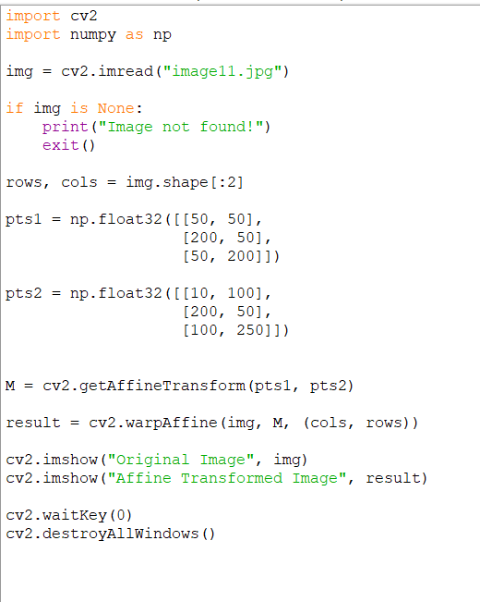
Sample Input: Output:
